What is a Web Application Firewall (WAF)?
A WAF or web application firewall helps protect web applications by filtering and monitoring HTTP traffic between a web application and the Internet. It typically protects web applications from attacks such as cross-site forgery, cross-site-scripting (XSS), file inclusion, and SQL injection, among others.
A WAF is a protocol layer 7 defense (in the OSI model), and is not designed to defend against all types of attacks. This method of attack mitigation is usually part of a suite of tools which together create a holistic defense against a range of attack vectors.
By deploying a WAF in front of a web application, a shield is placed between the web application and the Internet. While a proxy server protects a client machine’s identity by using an intermediary, a WAF is a type of reverse-proxy, protecting the server from exposure by having clients pass through the WAF before reaching the server.
A WAF operates through a set of rules often called policies. These policies aim to protect against vulnerabilities in the application by filtering out malicious traffic. The value of a WAF comes in part from the speed and ease with which policy modification can be implemented, allowing for faster response to varying attack vectors; during a DDoS attack, rate limiting can be quickly implemented by modifying WAF policies.
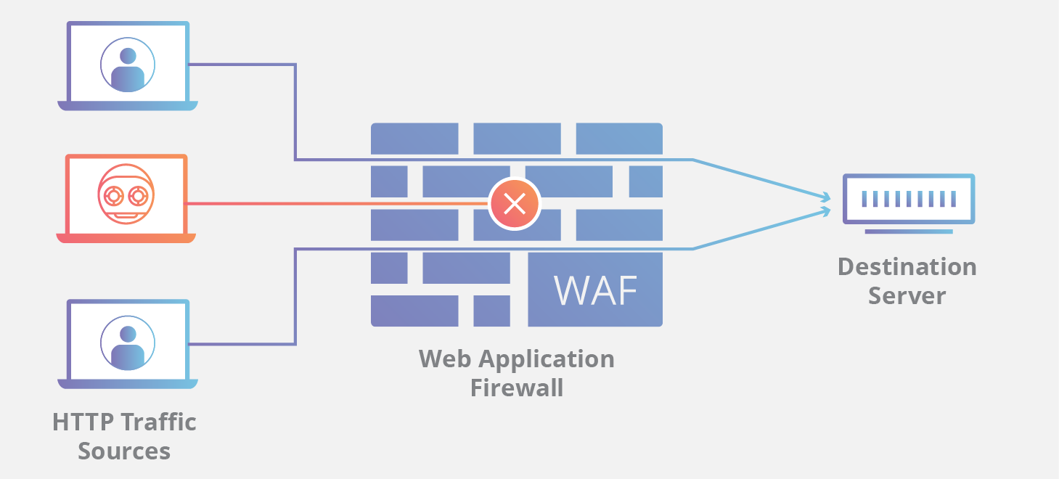
Report
2025 Security Signals Report
Get the report

What is the difference between blocklist and allowlist WAFs?
A WAF that operates based on a blocklist (negative security model) protects against known attacks. Think of a blocklist WAF as a club bouncer instructed to deny admittance to guests who don’t meet the dress code. Conversely, a WAF based on an allowlist (positive security model) only admits traffic that has been pre-approved. This is like the bouncer at an exclusive party, he or she only admits people who are on the list. Both blocklists and allowlists have their advantages and drawbacks, which is why many WAFs offer a hybrid security model, which implements both.
WAF Protection
Defend against “Top 10” attack techniques
Learn more

What are network-based, host-based, and cloud-based WAFs?
A WAF can be implemented one of three different ways, each with its own benefits and shortcomings:
- A network-based WAF is generally hardware-based. Since they are installed locally they minimize latency, but network-based WAFs are the most expensive option and also require the storage and maintenance of physical equipment.
- A host-based WAF may be fully integrated into an application’s software. This solution is less expensive than a network-based WAF and offers more customizability. The downside of a host-based WAF is the consumption of local server resources, implementation complexity, and maintenance costs. These components typically require engineering time, and may be costly.
- Cloud-based WAFs offer an affordable option that is very easy to implement; they usually offer a turnkey installation that is as simple as a change in DNS to redirect traffic. Cloud-based WAFs also have a minimal upfront cost, as users pay monthly or annually for security as a service. Cloud-based WAFs can also offer a solution that is consistently updated to protect against the newest threats without any additional work or cost on the user’s end. The drawback of a cloud-based WAF is that users hand over the responsibility to a third party, therefore some features of the WAF may be a black box to them. (A cloud-based WAF is one type of cloud firewall; learn more about cloud firewalls.)
Learn how a connectivity cloud lets companies protect their websites with a cloud-based WAF solution.

